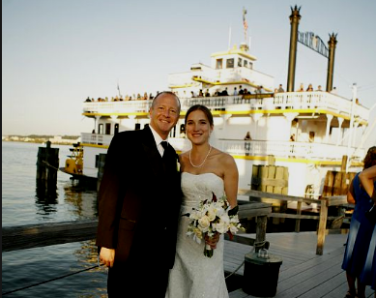

1- Someday My Prince Will Come
2- Gavotte
3- Three To Get Ready
4- Bodhisattva
5- Babe It Ain’t No Lie
6- Sunny Side Of The Street
7- Chain Lightning
8- Forty Five Degrees
9- Gong Show Song
10- Fur Elyse
11- Autumn Leaves
12- Show Goes On
13- Kansas City
14- Lullaby Of Birdland
15- Harbor Lights
16- Mexico
17- Margaritaville
18- Signe
19- Shape Of My Heart
20- Valley Road
21- The Way It Is
22- Tuxedo Junction
23- A Taste Of Honey
24- Saint Anthony Chorale
25- Southern Cross
26- Call Me Al
27- Here Comes The Bride
28- Ode To Joy

